10.1.7 Editors - Geometry Nodes Editor - Header - Add Menu - Color
Detailed table of content 1
Add menu - Color 2
Color Ramp 2
Combine RGB 4
Separate RGB 4

Detailed table of content
Detailed table of content
Detailed table of content 1
Add menu - Color 2
Color Ramp 2
Inputs 2
Factor 2
Properties 2
Color Ramp 2
Controls 2
+ 2
- 2
Tools menu 2
Flip Color Ramp 2
Distribute Stops from Left 2
Distribute Stops Evenly 2
Eyedropper (pipette icon) E 3
Reset Color Ramp 3
Color Mode 3
RGB 3
HSV/HSL 3
Interpolation 3
Ease 3
Cardinal 3
Linear 3
B-Spline 3
Constant 3
Color Ramp 3
Active Color Stop elements 3
Choose active color stop 3
Pos 3
Outputs 3
Image 3
Alpha 4
Combine RGB 4
Input 4
R, G and B 4
Output 4
Color 4
Separate RGB 4
Input 4
Image 4
Output 4
R, G and B 4

Add menu - Color
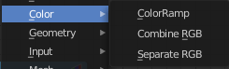
Here you find mainly nodes to convert color values.

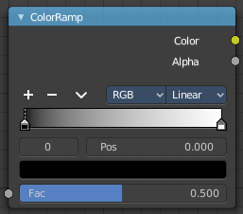
Color Ramp
The Color Ramp Node is used for mapping values to colors with the use of a gradient.

Inputs

Factor
The Factor input is used as an index for the color ramp.

Properties

Color Ramp
Color Ramps enables the user to specify a range of colors based on color stops. The color between the color stops gets interpolated.

Controls

+
Add a stop to your color ramp. The stop will be added after the selected one, in the middle to the next one.

-
Deletes the selected color stop from the list.


Tools menu

Flip Color Ramp
Flips the gradient, inverting the values of the color ramp.

Distribute Stops from Left
Rearrange the stops so that every step has the same space to the right.

Distribute Stops Evenly
Space between all neighboring stops becomes equal.

Eyedropper (pipette icon) E
An Eyedropper to sample a color or gradient from the interface to be used in the color ramp.

Reset Color Ramp

Resets the color ramp to its default state.

Color Mode

RGB
Blends color by mixing each color channel and combining.

HSV/HSL
Blends colors by first converting to HSV or HSL, mixing, then combining again. This has the advantage of maintaining saturation between different hues, where RGB would de-saturate, this allows for a richer gradient.


Interpolation

Ease
Uses an Ease Interpolation for the color stops.

Cardinal
Uses a Cardinal Interpolation for the color stops.

Linear
Uses a Linear Interpolation for the color stops.

B-Spline
Uses a B-Spline Interpolation for the color stops.

Constant
Uses a Constant Interpolation for the color stops.

Color Ramp
The color band. A click at one of the color stops makes it the active one. You can move the color stops by clicking at them and dragging them around.

Active Color Stop elements

Adjust the active color stop.

Choose active color stop
Choose the color stop by index.

Pos
The position of the active color stop. The range goes from 0.000 to 1.000

Outputs

Image
Standard image output.

Alpha

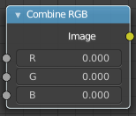
Combine RGB
Combine the single RGB channels into a single image.

Input

R, G and B
The red, green and blue channels of an image.

Output

Color
Color output.

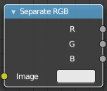
Separate RGB
Combine the single RGB channels into a single image.

Input

Image
The image input.

Output

R, G and B
The red, green and blue channels of an image.

